**Raditya Surya Pratama**

**Radu Alexandru Stoica**

Game

Abstract Factory Pattern

INTRODUCTION

The fourth assignment for DPR is to implement the abstract factory pattern into a smurf/minion game application. This application is working to simulate how abstract factory pattern works, by choosing the minion or smurf character to start the game.

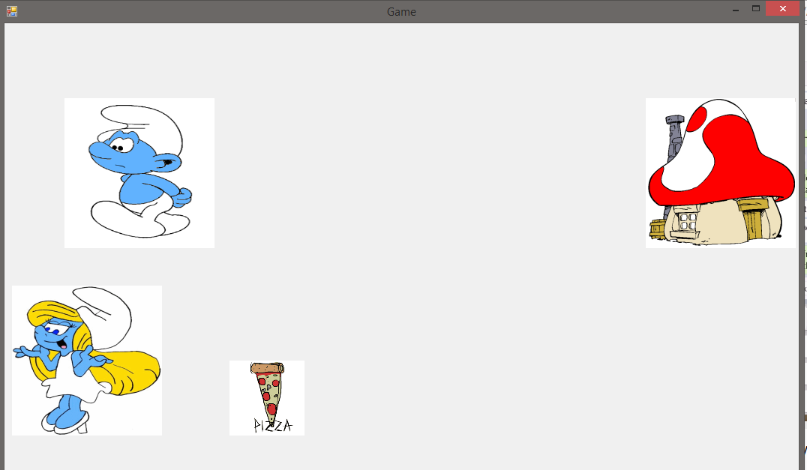

ABSTRACT FACTORY PATTERN

Abstract factory offers the interface for creating a family or related objects, without explicitly specifying their classes. Abstract Factory separates the implementation details of an object from their general use and reilies on the object composition, and the methods is exposed in the factory interfaces.

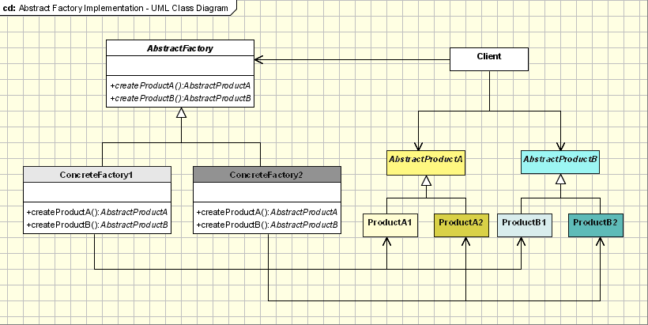

Source: http://www.oodesign.com/abstract-factory-pattern.html

UML DIAGRAM

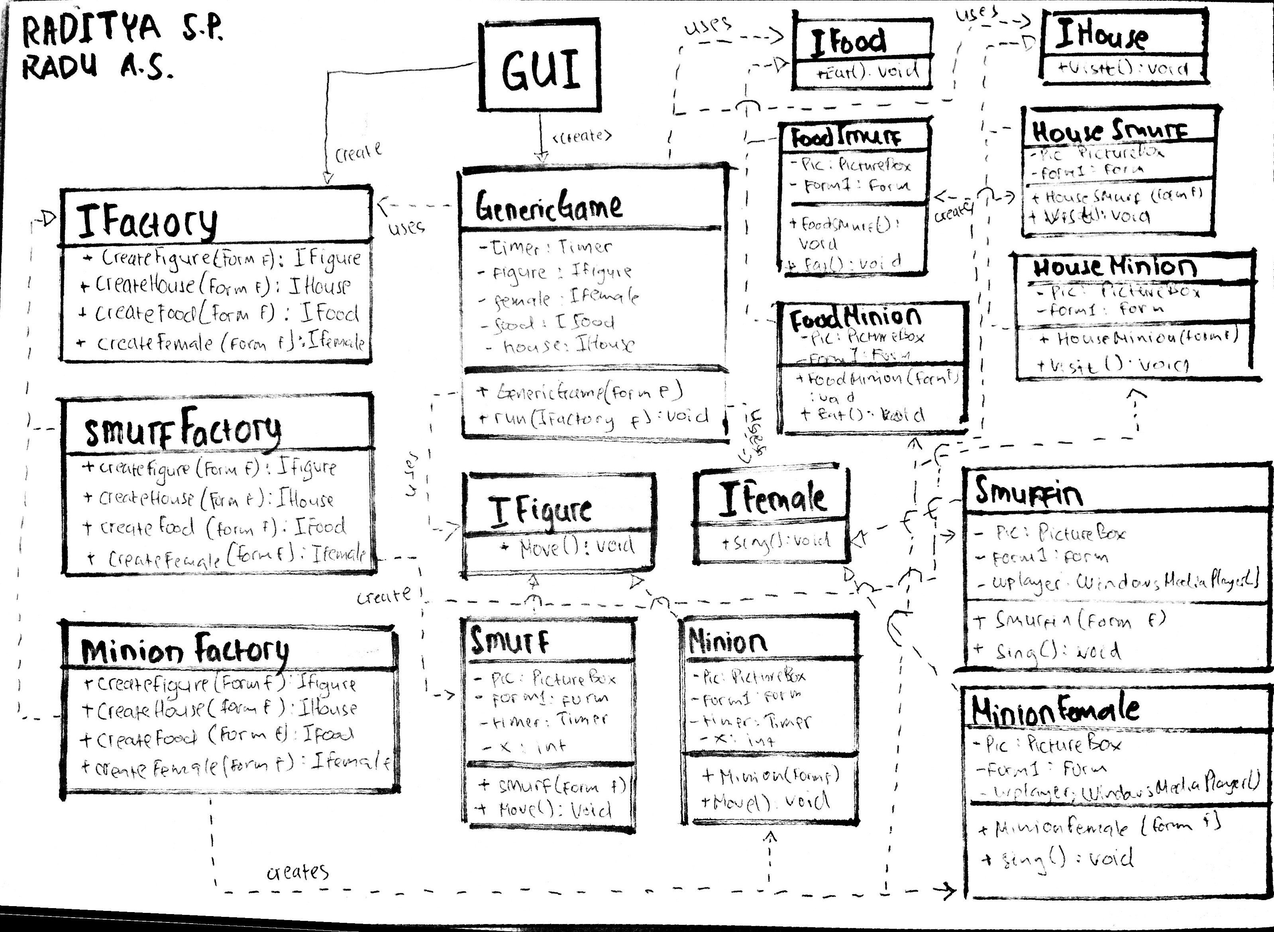

REUSABILITY

The reusability of our code is represented by the classes that available in the application could be used or reused by another component.

In this case, our application the Smurf or Minion factories could be reused in the application for minion or smurf related functionality.

EXTENSIBILITY

The extensibility of our code is represented by the implementation of the ConcreteFactory which is represented by IFactory, so the implementation of that factory allows an extension or integration of new functionality (E.g. SmurfFactory, MinionFactory).

MAINTAINABILITY

For the maintainability matters in the application, the classes should be easily changed or updated. In this case, the maintainability is supported by the separation of independent objects of product, for example the ConcreteFactory (SmurfFactory or MinionFactory) and the Products.

PATTERN DOWNSIDE

There are a couple of disadvantages of using the Abstract Factory pattern:

* Interface might need to be modified for all factories if there are any changes to any underlying detail of one factory.
* Difficult to support new kinds of product

Source: http://stackoverflow.com/questions/19508928/what-are-disadvantages-of-abstract-factory-design-pattern

UNIT TEST

The unit test is included in the project solution.